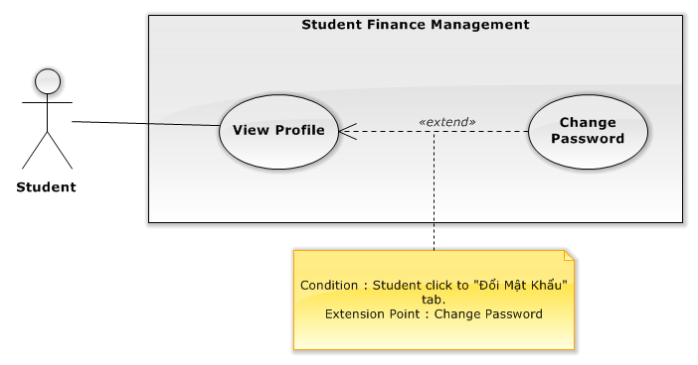

|  |  |  |  |
| --- | --- | --- | --- |
| **USE CASE – STU001** | | | |
| **Use Case No.** | STU001 | **Use Case Version** | 1.0 |
| **Use Case Name** | View Profile | | |
| **Author** | Vu Nhat Anh Khoa | | |
| **Date** | 26/09/2015 | **Priority** | Normal |
| **Actor:**   * Student   **Summary:**   * This use case allows users to view their profile.   **Goal:**   * User cans review their personal information.   **Triggers:**   * User clicks on the Avatar icon on the top right of the screen, then clicks to “Profile ”   Button.  **Preconditions:**   * User logs in with Student role   **Post Conditions:**   * **Success**: The system successfully shows user’s profile information * **Fail:** The system shows an error message.   **Main Success Scenario:**   |  |  |  | | --- | --- | --- | | Step | Actor Action | System Response | | 1 | User clicks on the Avatar icon on the top right of the screen, then clicks to “Profile ”  Button. | Navigate user to their Profile screen and show information box containing detail information including:   * + User’s full name labeled as “Họ Và Tên”: text.   + User’s gender labeled as “Giới tính”: text   + User’s code labeled as “MSSV”: text.   + User’s personal identification number labeled as “CMND”: text.   + User’s email address labeled as “Email”: text   + User’s day of birth labeled as “Ngày sinh”: text   + User’s phone number labeled as “Số điện thoại”: text   + User’s address labeled as “Địa Chỉ” : text   + The phone number of user’s parent labeled as “Số điện thoại của phụ huynh”: text   + The email address of user’s parent labeled as “Email của phụ huynh”: text   + User’s tuition status labeled as “Tình trạng”: text   + The year user started school labeled as “Khóa nhập học”: text   + The term user’s started school labeled as “Học Kỳ Nhập Học”: text   + The started English level of user labeled as “Tiếng Anh Đầu Vào” : text |   **Alternative Scenario: N/A**  **Exceptions:**   |  |  |  | | --- | --- | --- | | No | Actor Action | System Response | | 1 | Cannot connect to server. | System shows error message: “Cannot connect to server.” |   **Relationships:** N/A  **Business Rules:**   * The system fetches user only their own profile information from the database. | | | |
|  | | | |

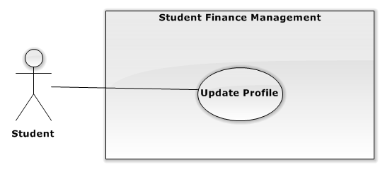

|  |  |  |  |
| --- | --- | --- | --- |
| **USE CASE – STU002** | | | |
| **Use Case No.** | STU002 | **Use Case Version** | 1.0 |
| **Use Case Name** | Update Profile | | |
| **Author** | Vu Nhat Anh Khoa | | |
| **Date** | 25/09/2015 | **Priority** | Normal |
| **Actor:**   * Student   **Summary:**   * This use case allows users to update their profile information.   **Goal:**   * New information is updated to system.   **Triggers:**   * User clicks “Cập Nhật Thông Tin” tab while on the Profile screen.   **Preconditions:**   * User logs in with Student role   **Post Conditions:**   * **Success**: The system successfully updates new information to database. * **Fail:** The system shows an error message.   **Main Success Scenario:**   |  |  |  | | --- | --- | --- | | Step | Actor Action | System Response | | 1 | User clicks “Cập Nhật Thông Tin” tab while on the Profile screen | * User’s phone number: free text input, required, length 8 – 15 * User’s address: free text input, required, length 3 – 250 * User’s parent phone number: free text input, required, length 8 - 15 * User’s parent email address: free text input, required, length 3 - 250 | | 2 | User alters the information in the form [Alternative Scenario] |  | | 3 | User clicks update button | * System updates new information to database. * Redirect user to Profile screen with new information presenting. |   **Alternative Scenario:**   |  |  |  | | --- | --- | --- | | Step | Actor Action | System Response | | 1 | User empties the fields |  | | 2 | User clicks update button | * System keeps current information in database. * Redirect user to Profile screen with current information presenting. |   **Exceptions:**   |  |  |  | | --- | --- | --- | | No | Actor Action | System Response | | 1 | Cannot connect to server. | System shows error message: “Cannot connect to server.” |   **Relationships:** N/A  **Business Rules:**   * User’s profile is always loaded from the system * In successful scenario, new information will be updated to the system * Reloaded Profile screen will show updated information * If user leave the fields blank, current information will be kept. | | | |

|  |  |  |  |
| --- | --- | --- | --- |
| **USE CASE – STU004** | | | |
| **Use Case No.** | STU004 | **Use Case Version** | 1.0 |
| **Use Case Name** | View Tuition Payment Status | | |
| **Author** | Vu Nhat Anh Khoa | | |
| **Date** | 25/09/2015 | **Priority** | Normal |
| **Actor:**   * Student   **Summary:**   * This use case allows users to view all their past tuition payments and the tuition payment status for the next semester.   **Goal:**   * A list of semesters with the tuition and payment status will be shown to user.   **Triggers:**   * User clicks “Trạng thái đóng học phí” tab on the navigation menu on the left.   **Preconditions:**   * User logs in with Student role   **Post Conditions:**   * **Success**: The system successfully shows a list of semesters with the tuition and payment status in tabular form. * **Fail:** The system shows an error message.   **Main Success Scenario:**   |  |  |  | | --- | --- | --- | | Step | Actor Action | System Response | | 1 | User clicks “Trạng thái đóng học phí” tab | * Navigate user to Tuition Payment Status screen * System will show a list of semesters with the tuition and payment status in tabular form and order by semester. * The table contain the following columns:   + First column contains order number labeled as “STT”.   + Second column contains the semester labeled as “Học Kỳ”.   + Third column contains the payment status labeled as “Trạng thái”.   + Fourth column contains the date of money transmission labeled as “Ngày Nộp”   + Fifth column contains the transmission deadline labeled as “Hạn chót”   + Sixth column contains the link to the detail transmission labeled as “Chi tiết” | | 2 | User clicks a “Chi tiết” link in the table | * System will show a pop-up page containing following information:   + User’s full name labeled as “Tên”: text.   + User’s code labeled as “MSSV”: text.   + The semester at which the transmission occurred labeled as “Học kỳ”: text.   + User’s tuition status labeled as “Tình trạng”: text   + The original tuition charge labeled as “Mức học phí”: text   + The deduction fees labeled as “Khoản trừ”: text   + The tuition charge after deduction labeled as “Cần Nộp”: text   + The tuition payment status labeled as “Trạng thái”: text   + The transmission date labeled as “Ngày nộp”: text   + The bank in which student transmit the fees from labeled as “Ngân hàng”: text |   **Alternative Scenario:** N/A  **Exceptions:**   |  |  |  | | --- | --- | --- | | No | Actor Action | System Response | | 1 | Cannot connect to server. | System shows error message: “Cannot connect to server.” |   **Relationships:** N/A  **Business Rules:**   * All information is loaded from the system’s database * The tuition status or “Tình trạng” have three values: “Học bổng”, “Tín dụng 50%”, and “Bình thường” * The tuition payment status or “Trạng thái” have two values: “Đã nộp” and “Chưa nộp” * In “Chi tiết” pop-up page, “Ngày nộp” will be blank if the tuition payment status (“Trạng thái”) is “Chưa nộp” | | | |

|  |  |  |  |
| --- | --- | --- | --- |
| **USE CASE – STU005** | | | |
| **Use Case No.** | STU005 | **Use Case Version** | 1.0 |
| **Use Case Name** | View Studied Subjects | | |
| **Author** | Vu Nhat Anh Khoa | | |
| **Date** | 25/09/2015 | **Priority** | Normal |
| **Actor:**   * Student   **Summary:**   * This use case allows users to view their past semesters and subjects.   **Goal:**   * A list of subjects from a chosen semester will be shown to user.   **Triggers:**   * User clicks “Các khóa đã học” tab on the navigation menu on the left. * User can choose a specific semester by selecting from a combo box at the top right of the information box.   **Preconditions:**   * User logs in with Student role   **Post Conditions:**   * **Success**: The system successfully shows a list of subjects in tabular form. * **Fail:** The system shows an error message.   **Main Success Scenario:**   |  |  |  | | --- | --- | --- | | Step | Actor Action | System Response | | 1 | User clicks “Các khóa đã học” tab | Navigate user to Finished Semesters screen and show information box containing the latest semester user has taken   * System will show a list of subjects in tabular form and order by subject code. * The table contain the following columns:   + First column contains order number labeled as “STT”.   + Second column contains subject code labeled as “Mã Môn”.   + Third column contains subject name labeled as “Tên Môn”.   + Fourth column contains the number of credits labeled as “Số Tín Chỉ”   + Fifth column contains the semester’s half information labeled as “Half”   + Sixth column contains the grade of the subject labeled as “Điểm Trung Bình”   + Seventh column contains the status of the subject labeled as “Trạng Thái”   + The last column contains additional note for specific subjects labeled as “Ghi Chú” | | 2 | User selects a specific semester from a scroll down box | * System will show a list of subjects in tabular form and order by subject code in different semester with the columns as the same as above |   **Alternative Scenario:** N/A  **Exceptions:**   |  |  |  | | --- | --- | --- | | No | Actor Action | System Response | | 1 | Cannot connect to server. | System shows error message: “Cannot connect to server.” |   **Relationships:** N/A  **Business Rules:**   * All data is loaded from the system’s database * “Trạng thái” column has only two value: “Passed” or “Failed” | | | |

|  |  |  |  |
| --- | --- | --- | --- |
| **USE CASE – STU006** | | | |
| **Use Case No.** | STU006 | **Use Case Version** | 1.0 |
| **Use Case Name** | View Incomplete Subjects | | |
| **Author** | Vu Nhat Anh Khoa | | |
| **Date** | 26/09/2015 | **Priority** | Normal |
| **Actor:**   * Student   **Summary:**   * This use case allows users to view their incomplete subjects.   **Goal:**   * A list of subjects that were failed or didn’t meet the requirements will be shown to user.   **Triggers:**   * User clicks “Các môn chưa hoàn thành” tab on the navigation menu on the left.   **Preconditions:**   * User logs in with Student role   **Post Conditions:**   * **Success**: The system successfully shows a list of subjects in tabular form. * **Fail:** The system shows an error message.   **Main Success Scenario:**   |  |  |  | | --- | --- | --- | | Step | Actor Action | System Response | | 1 | User clicks “Các môn chưa hoàn thành” tab | Navigate user to Incomplete Subjects screen and show information box containing the subjects that didn’t meet requirements   * System will show a list of subjects in tabular form and order by subject code. * The table contain the following columns:   + First column contains order number labeled as “STT”.   + Second column contains subject code labeled as “Mã Môn”.   + Third column contains subject name labeled as “Tên Môn”.   + Fourth column contains the number of credits labeled as “Số Tín Chỉ”   + Fifth column contains the semester the subjects took place labeled as “Học kỳ”   + Sixth column contains the status of the subject labeled as “Trạng Thái”   + The last column contains additional note for specific subjects labeled as “Ghi Chú” |   **Alternative Scenario:** N/A  **Exceptions:**   |  |  |  | | --- | --- | --- | | No | Actor Action | System Response | | 1 | Cannot connect to server. | System shows error message: “Cannot connect to server.” |   **Relationships:** N/A  **Business Rules:**   * All data is loaded from the system’s database * “Trạng thái” column has only two value: “Failed” or “Chưa đủ điều kiện” | | | |